The University of Azad Jammu and Kashmir, Muzaffarabad

Name: Alishba Zakir
Roll No: 2024-SE-02
Course: DataBase Systems
Course Code: CS-2204
Lab: 07
Submitted To: Engr. Awais Rathore
Submitted By: Alishba Zakir
Date: Mar, 2026

Department Of Software Engineering

Filter: Part 02
In a database, a filter is a mechanism used to screen, narrow down, and extract specific records from a table based on user-defined conditions. Instead of viewing an entire dataset, a filter isolates only the rows that meet your exact criteria, hiding the rest.
How Filters Work in a Database
Filtering is primarily performed using the WHERE clause in an SQL query. The database engine scans the table row by row, evaluates the condition you set, and returns only the rows where the condition is TRUE.
- The BETWEEN operator :
in SQL is used to filter query results by matching values within a specific, inclusive range. It is a logical operator commonly used in the WHERE clause to filter numbers, text, or dates.
How it Works
When you use BETWEEN, the database includes both the start value and the end value in the results.
1: list employee with salary between 75,00 and 100,00:
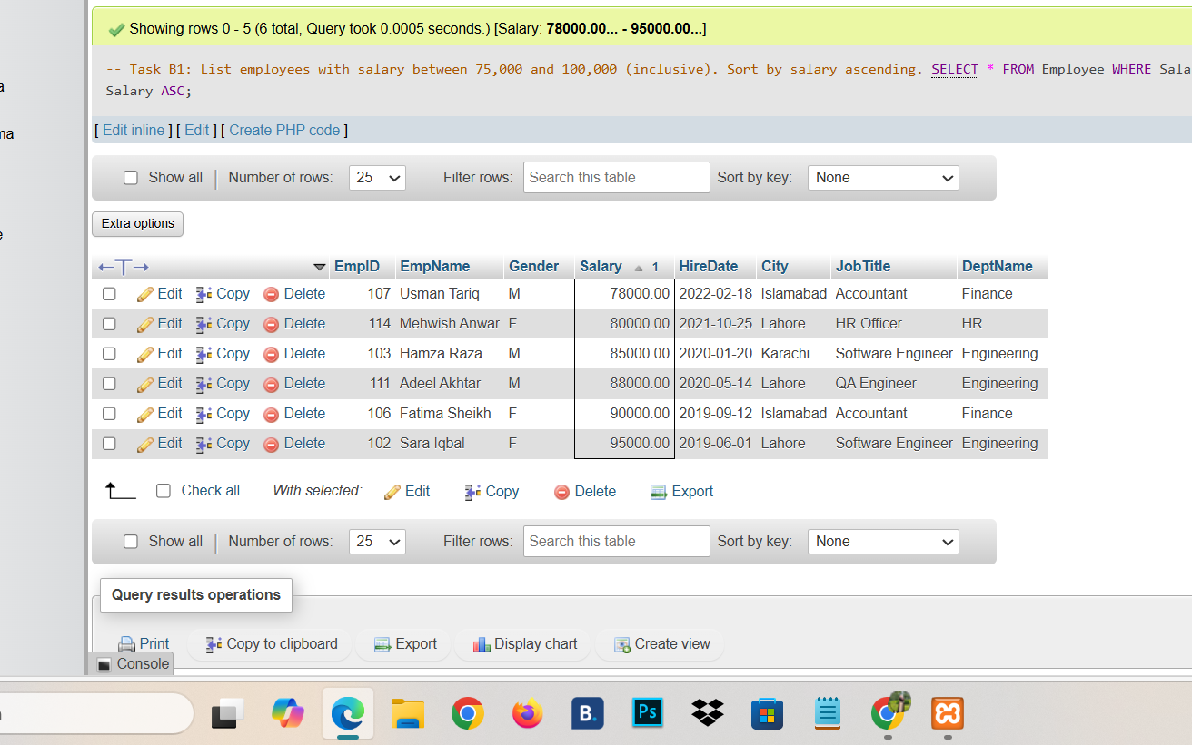
2: list employee hired between January 2020 and December2022 :

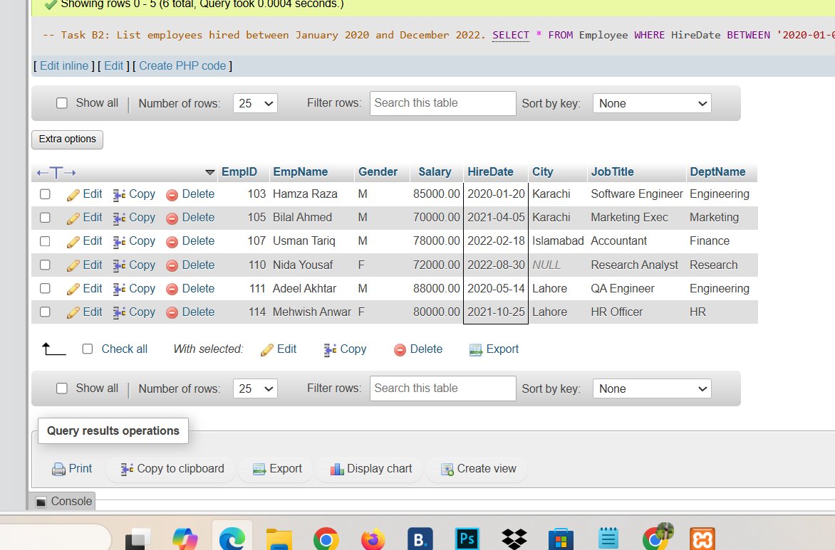
3: Salary not between 80and 10,000:
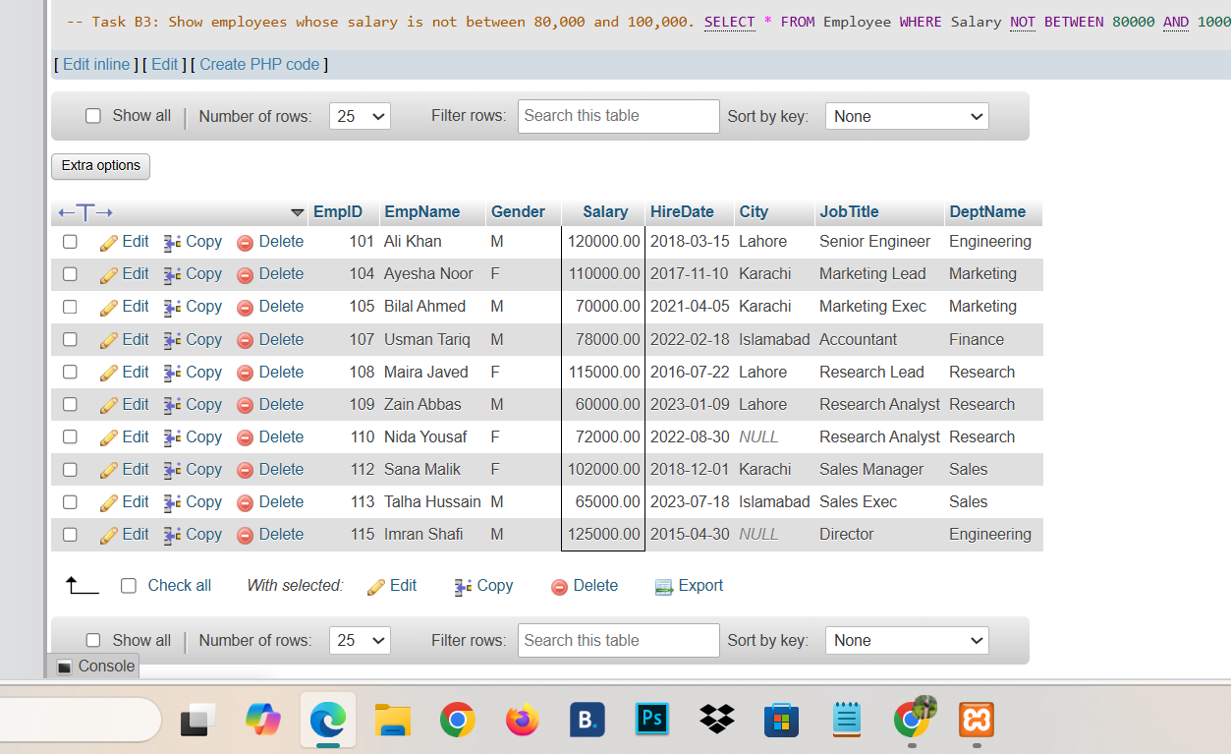
4: List employee whose city is one of Lahore,Islamad and salary is sorting by decending order:
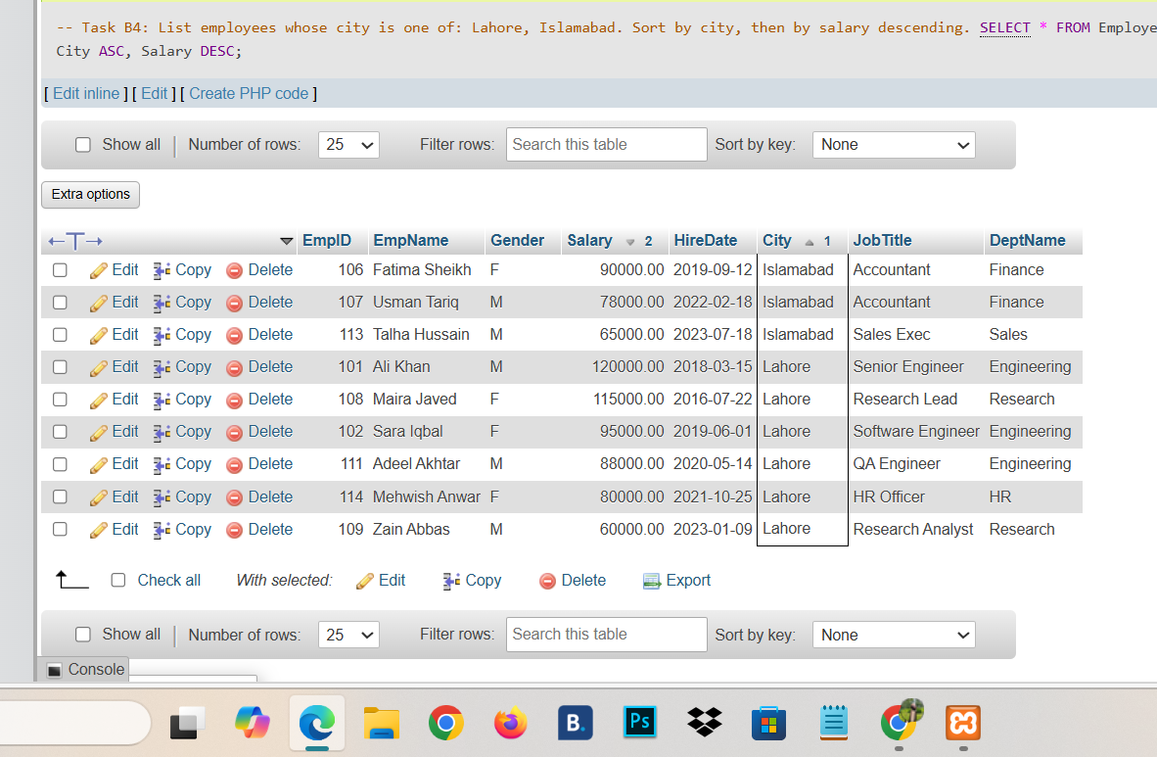
5: find Employee is any department except Engineering ,Sale,HR

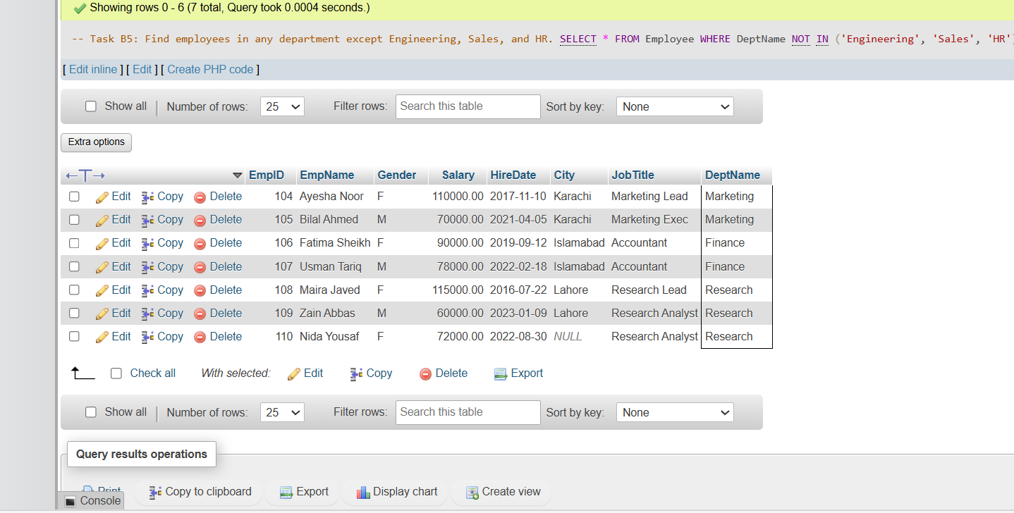

6: show all employee whose name started with M:
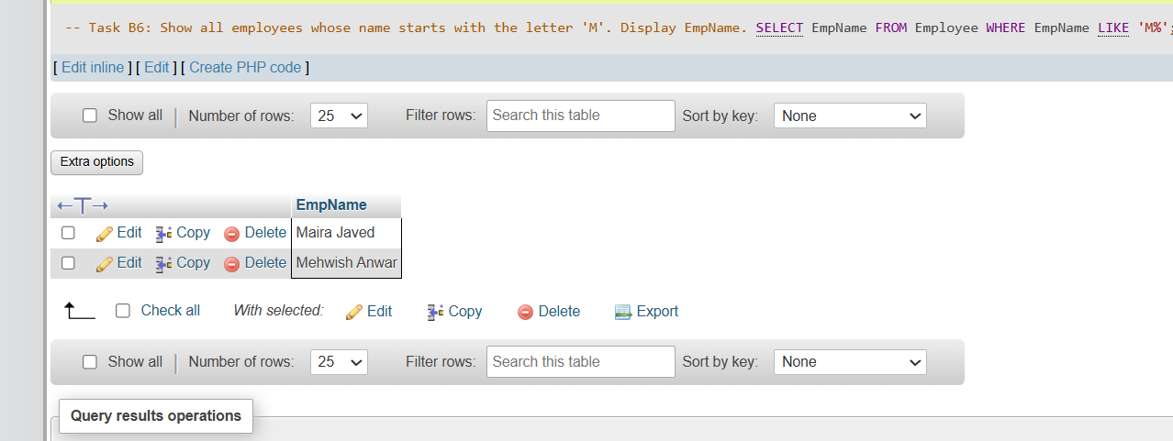
7: find employee whose name contain a :
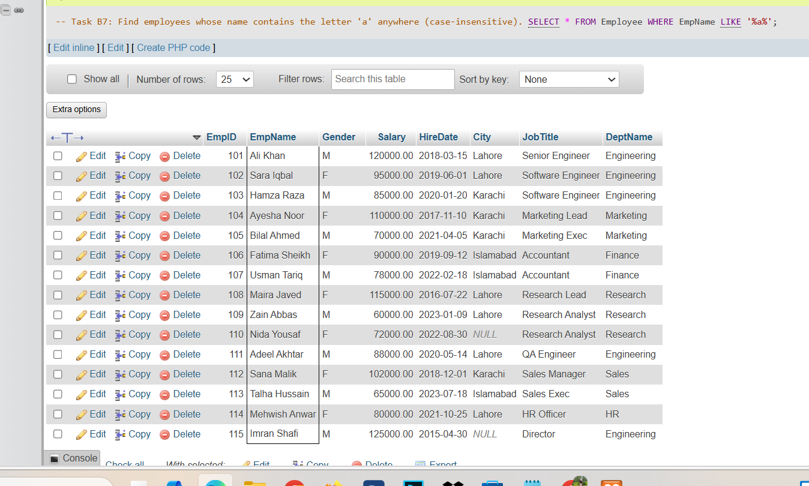

8: find employee whose name end with an :

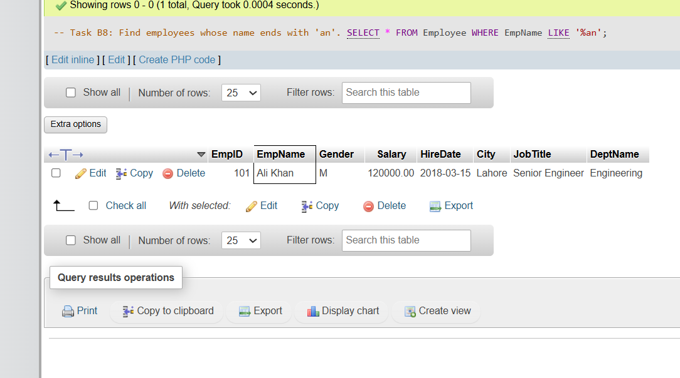

9: find employee whose job title contain Engineeering but not work in engineering :

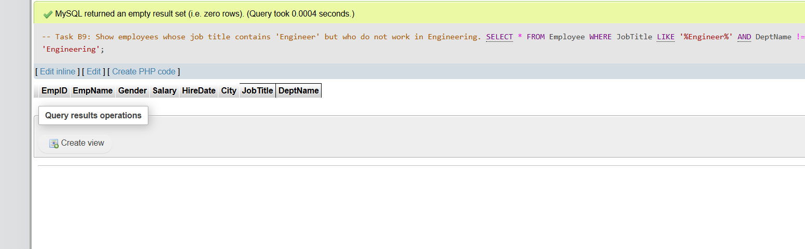
10: list employee whose donot have recorded city:

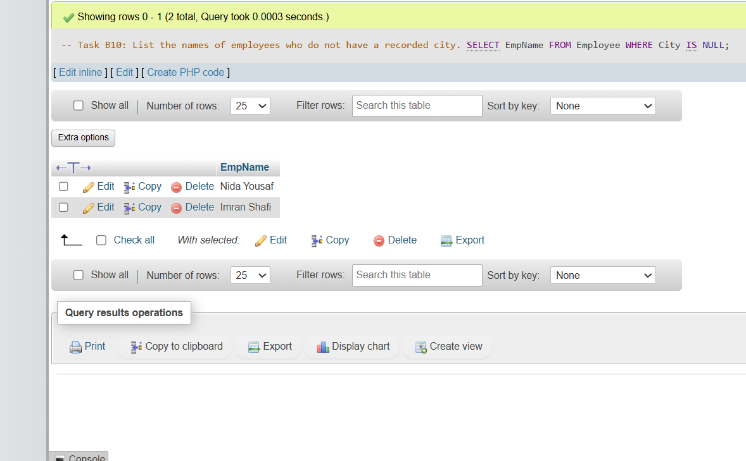
11: list employee whose have recorded city:
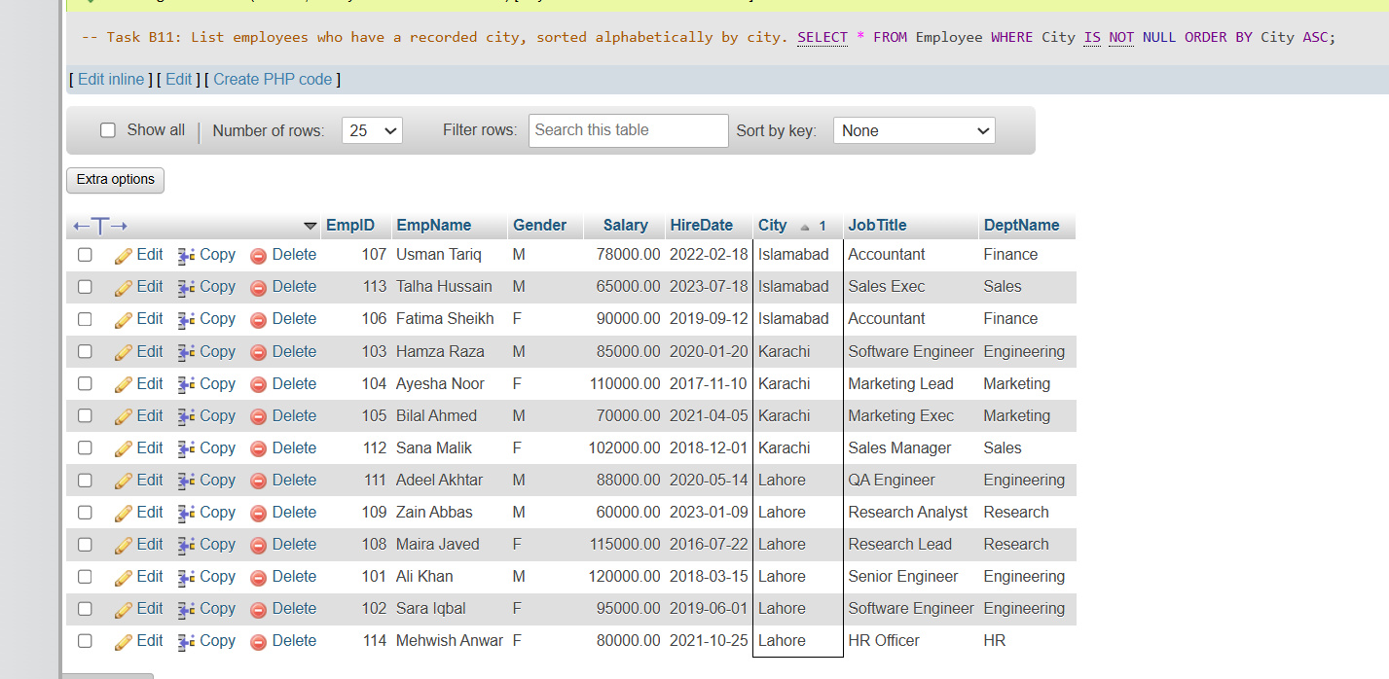
12: Display the 3 higest paid employee:
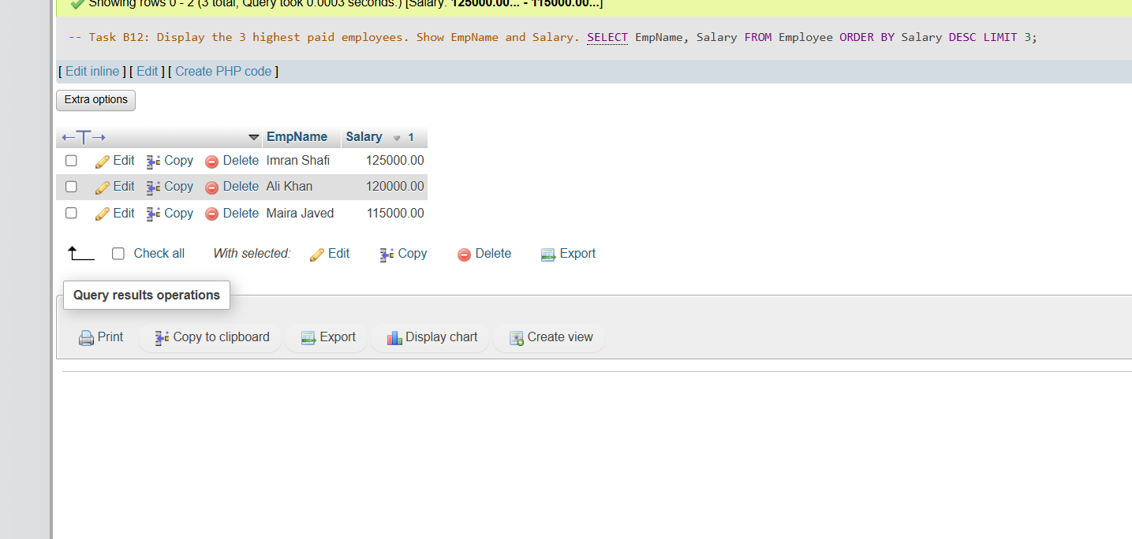
13: Display the 5 most recently higest paid employee:

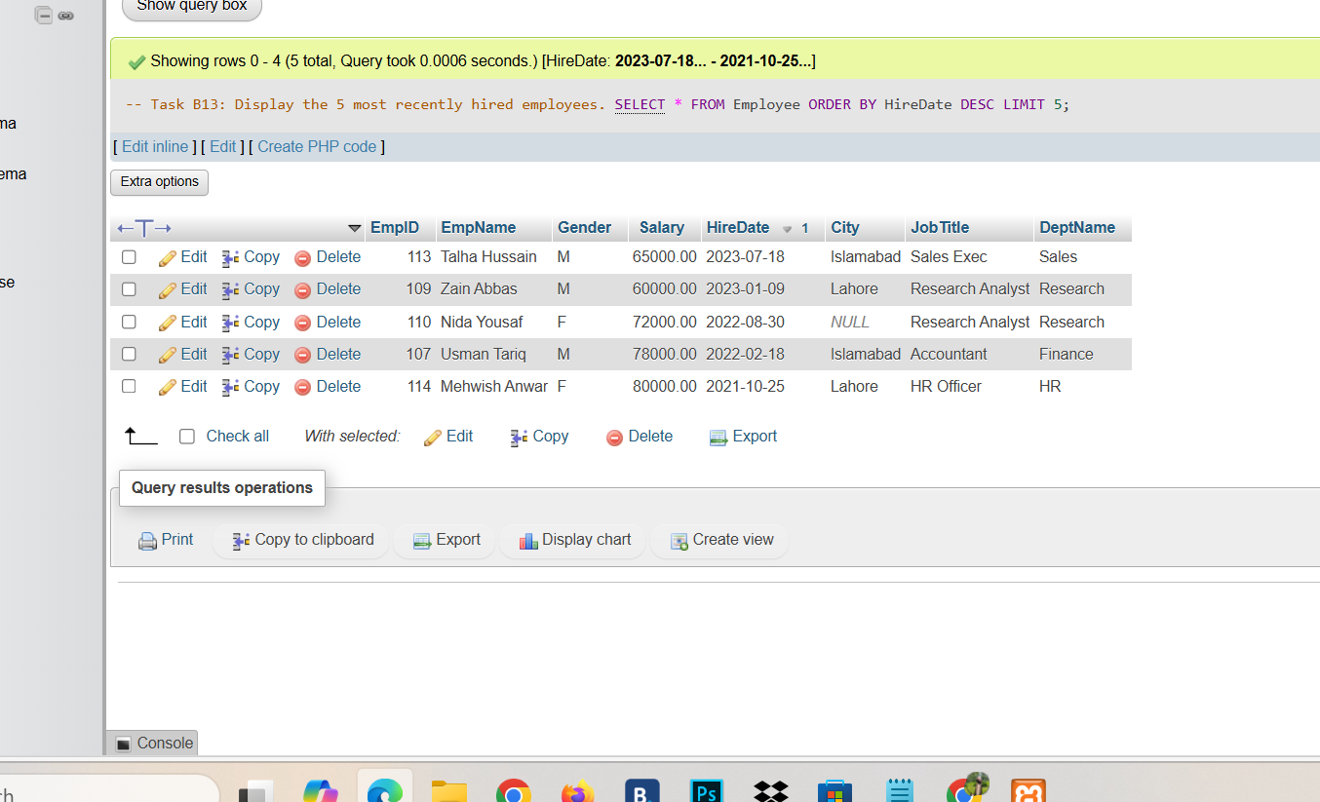

14: Display the 3 bottom scalary in Company:

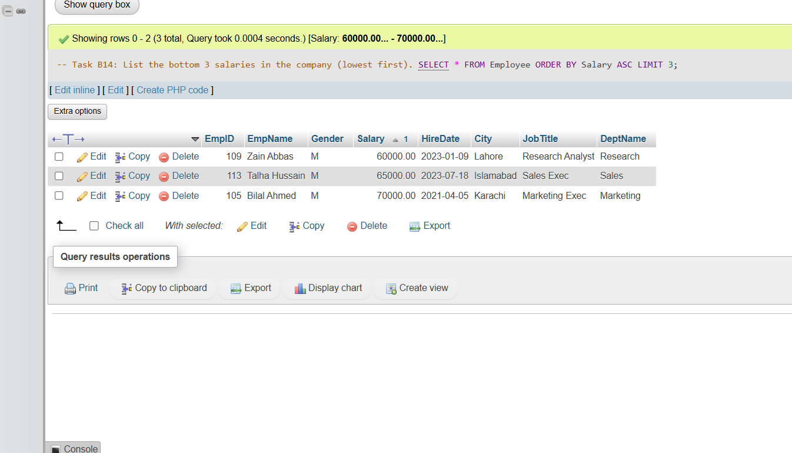
15: show all em,sorted by department accending ,then by hired date decending :
